SESSION 9
Probability Distributions (Continuous)
Normal Distribution and Z-scores: Assignment Notes with Worked Demo

1. Normal Distribution

1.1 Continuous random variables
A continuous random variable can take any value in an interval, such as sales amount, height, weight or time. Its distribution is described by a probability density function (PDF), drawn as a curve.
- Probability is area: P(a < X < b) is the area under the curve between a and b.
- Single values: for a continuous variable P(X = x) = 0, so we always ask about ranges such as P(X > 6000).
- Total area: the whole area under the curve is 1.
- Cumulative probability: P(X ≤ x) is the area to the left of x (the CDF).

1.2 The normal distribution
The normal distribution is the familiar bell-shaped curve. It is completely described by two parameters: the mean μ, which sets the centre, and the standard deviation σ, which sets the spread. We write X ~ N(μ, σ²).
f(x) = 1 / (σ × √(2π)) × e^( −(x − μ)² / (2σ²) )

1.3 Properties
- Symmetric: the curve is symmetric about μ, so the left and right halves are mirror images.
- Mean = median = mode: all three sit at the centre of the curve.
- Spread: a larger σ gives a wider, flatter curve; a smaller σ gives a narrower, taller one.
- Tails: the curve never touches the x-axis, but values far from μ are extremely rare.

1.4 The empirical rule (68-95-99.7)
Range | Share of values | Interpretation
μ ± 1σ | About 68% | Roughly two-thirds of values
μ ± 2σ | About 95% | Almost all values
μ ± 3σ | About 99.7% | Nearly every value; outside it is rare

1.5 Example
Question: Order values follow a normal distribution with mean Rs. 5,000 and standard deviation Rs. 800. Between which values do the middle 95% of orders lie?
Solution: Use μ ± 2σ.
- Lower limit: 5000 − 2 × 800 = Rs. 3,400
- Upper limit: 5000 + 2 × 800 = Rs. 6,600
About 95% of orders lie between Rs. 3,400 and Rs. 6,600.

2. Z-scores

2.1 Definition
A z-score tells us how many standard deviations a value is away from the mean. It converts a value from any normal distribution onto a common scale.
z = (x − μ) / σ
- Positive z: the value is above the mean.
- Negative z: the value is below the mean.
- z = 0: the value equals the mean.
- Rule of thumb: values with |z| > 3 are very unusual and are often flagged as outliers.

2.2 Example
Question: With μ = 5000 and σ = 800, find the z-score of an order of Rs. 6,500 and of an order of Rs. 3,800.
- Rs. 6,500: z = (6500 − 5000) / 800 = 1.875 (about 1.9 standard deviations above the mean)
- Rs. 3,800: z = (3800 − 5000) / 800 = −1.5 (1.5 standard deviations below the mean)

2.3 Finding a value from a z-score
Rearranging the formula gives the original value from a z-score.
x = μ + z × σ
For z = 1.2816 (the 90th percentile) with μ = 5000 and σ = 800: x = 5000 + 1.2816 × 800 = Rs. 6,025.

2.4 Comparing across different distributions
Z-scores let us compare values measured on different scales. Store A has μ = 5000, σ = 800 and a sale of Rs. 5,600 (z = 0.75). Store B has μ = 6000, σ = 1200 and a sale of Rs. 7,200 (z = 1.00). Store B has the larger sale in rupees and also the higher z-score, so it is the stronger result relative to its own usual sales.

3. Standard Normal Curve

3.1 Definition
The standard normal distribution is the normal distribution with mean 0 and standard deviation 1, written Z ~ N(0, 1). Every normal variable becomes standard normal after the z-score transformation, so a single table or function covers all normal problems.
f(z) = 1 / √(2π) × e^( −z² / 2 )

3.2 Reading probabilities
- Left-tail area: the standard normal table (or the CDF) gives P(Z ≤ z).
- Right-tail area: P(Z > z) = 1 − P(Z ≤ z).
- Between two values: P(a < Z < b) = P(Z ≤ b) − P(Z ≤ a).
- Symmetry: P(Z ≤ −z) = 1 − P(Z ≤ z).

3.3 Key values
z-value | P(Z ≤ z) | Common use
0 | 0.5000 | The mean: half the values lie below it
1.00 | 0.8413 | One standard deviation above the mean
1.28 | 0.9000 | 90th percentile
1.645 | 0.9500 | 95th percentile (one-sided 5% test)
1.96 | 0.9750 | 97.5th percentile (95% confidence interval)
2.576 | 0.9950 | 99.5th percentile (99% confidence interval)

3.4 Example
Question: Order values are N(5000, 800²). Find the probability that an order exceeds Rs. 6,000.
Solution: Convert to a z-score and use the standard normal curve.
- Z-score: z = (6000 − 5000) / 800 = 1.25
- Left area: P(Z ≤ 1.25) = 0.8944
- Right area: P(X > 6000) = 1 − 0.8944 = 0.1056
About 10.6% of orders are above Rs. 6,000.

4. Working with the Normal Distribution in Python
The scipy.stats module provides norm, which takes the mean (loc) and standard deviation (scale):
- norm.pdf(x, mu, sigma): height of the density curve at x, used for plotting.
- norm.cdf(x, mu, sigma): cumulative probability P(X ≤ x).
- norm.sf(x, mu, sigma): right-tail probability P(X > x).
- norm.ppf(q, mu, sigma): the value below which a share q of the data lies (percentile).
- norm.rvs(mu, sigma, size): random samples from the distribution.
Calling these without mu and sigma uses the standard normal N(0, 1). Matplotlib is used to draw a histogram of the data and the fitted curve.

5. Demo: Plot Normal Distribution of Sales Amounts

5.1 Problem statement
A retailer has the value of 500 orders. Check whether the sales amounts follow a normal distribution by plotting them, estimate the mean and standard deviation, and use the fitted model to answer business questions. The values are simulated for this demo with a mean of Rs. 5,000 and a standard deviation of Rs. 800.

5.2 Python code
import numpy as np
import matplotlib.pyplot as plt
from scipy.stats import norm

# Order values in Rs. - simulated for illustration
np.random.seed(9)
sales = np.random.normal(loc=5000, scale=800, size=500)

mu = sales.mean()
sigma = sales.std(ddof=1)
print("Mean:", round(mu, 2))
print("Std dev:", round(sigma, 2))

# Probabilities from the fitted normal model
print("P(X > 6000):", round(norm.sf(6000, mu, sigma), 4))
print("P(4200 < X < 5800):", round(norm.cdf(5800, mu, sigma) - norm.cdf(4200, mu, sigma), 4))
print("Z-score of 6500:", round((6500 - mu) / sigma, 2))
print("90th percentile:", round(norm.ppf(0.90, mu, sigma), 2))

# Histogram with fitted normal curve
x = np.linspace(mu - 4 * sigma, mu + 4 * sigma, 300)
plt.hist(sales, bins=25, density=True, alpha=0.6, label="Sales data")
plt.plot(x, norm.pdf(x, mu, sigma), color="red", label="Normal curve")
plt.axvline(mu, color="black", linestyle="--", label="Mean")
plt.xlabel("Sales amount (Rs.)")
plt.ylabel("Density")
plt.title("Distribution of Sales Amounts")
plt.legend()
plt.show()

5.3 Output
Mean: 5035.67
Std dev: 799.01
P(X > 6000): 0.1137
P(4200 < X < 5800): 0.6828
Z-score of 6500: 1.83
90th percentile: 6059.64

5.4 Normal curve
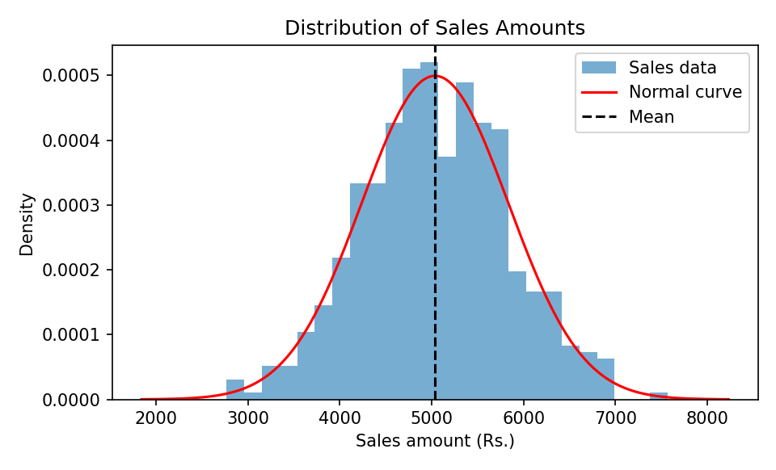
Figure 1: Histogram of sales amounts with the fitted normal curve

5.5 Fitted model
Sales ~ N(μ = 5035.67, σ = 799.01)

5.6 Interpretation
- Shape: the histogram is bell-shaped and symmetric around the mean, and the red curve follows the bars closely, so a normal model is reasonable.
- Empirical rule check: in the data, 68.4% of orders lie within one standard deviation of the mean and 95.2% within two, very close to 68% and 95%.
- High-value orders: P(X > 6000) = 0.1137, so about 11% of orders exceed Rs. 6,000. In the data, 11.4% of orders did.
- Typical range: P(4200 < X < 5800) = 0.6828, so about 68% of orders fall between Rs. 4,200 and Rs. 5,800.
- Z-score: an order of Rs. 6,500 has z = 1.83, which is high but not unusual (well below the |z| > 3 cut-off).
- Percentile: the 90th percentile is about Rs. 6,060, meaning 90% of orders are below that value. This can be used to set a threshold for premium customers.
- Caution: real sales data is often right-skewed because a few very large orders pull the tail upwards. Always plot the data before assuming normality.

Key Takeaways
- Normal distribution: a symmetric bell curve defined by μ and σ. Probability is the area under the curve.
- Empirical rule: about 68%, 95% and 99.7% of values lie within 1, 2 and 3 standard deviations of the mean.
- Z-score: z = (x − μ) / σ measures distance from the mean in standard deviations and allows comparison across scales.
- Standard normal: N(0, 1). Convert any normal value to z, then read the probability from the table or the CDF.
- Python: norm.pdf(), cdf(), sf() and ppf() from scipy.stats, plus a matplotlib histogram to check the fit.

